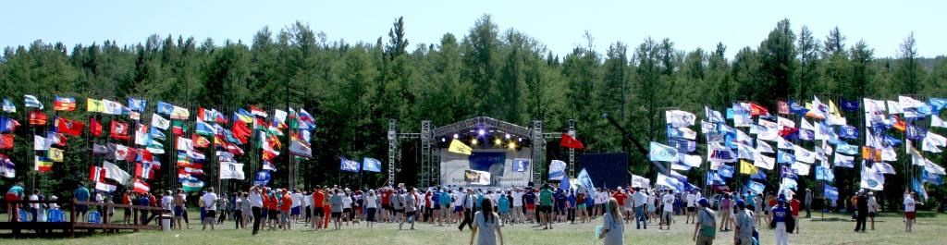
Reference information of the Forum "Engineers of the Future"

The Forum "Engineers of the Future" is a summer educational camp for young engineers, designers and technologists. About 2 000 young representatives of the global engineering community come together here for designing and joint implementation of projects and programs, which are aimed at the development of mechanical engineering and allied industries.
For last 5 years the event was attended by about 10 000 young specialists, scientists, graduate and undergraduate students. Young engineers from 380 industrial companies and 80 institutes from 60 regions of the Russian Federation became the participants of the Forum.
The average age of the Forum members is 26-28 years old.
The main target audience for the Forum is the heads of structural divisions of industrial companies, young professionals, students and postgraduates of higher educational institutions, representatives of youth public organizations.
The program of activities of the Sixth International Youth Industrial Forum "Engineers of the Future 2016" will include the following main units:
1. Educational program;
2. Business program;
3. Cultural program;
4. Sports program.
The main units of Educational program of the Forum "Engineers of the Future 2016", which are formed on the key areas of activity of engineering enterprises of the Russian Federation, are the follows:
● Engineering and Design Faculty;
● Engineering and Technological Faculty;
● Organization of production Faculty;
● Effective management Faculty;
● System engineering Faculty;
● Radio electronics Faculty;
● IT and robotics Faculty;
● Aerospace Faculty;
● Investment management Faculty;
● Business management (high tech industries) Faculty;
● "Technical BREAKTHROUGH" Faculty.
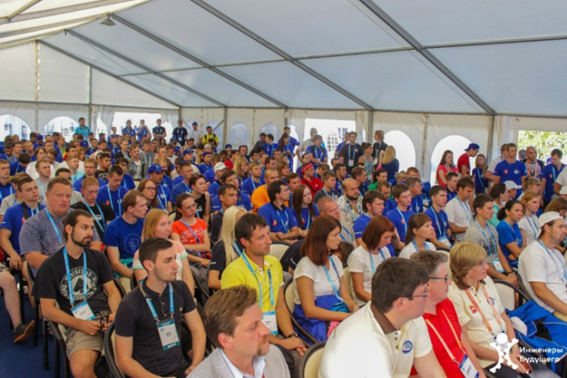
Educational program consists of the following programs of corporate universities and industrial enterprises of the country. It is formed by more than 60 Russian companies and universities, which cooperate with the Russian Engineering Union or are its members in different areas. Among them: "OBORONPROM" (Defence Industries Corporation), "Vnesheconombank" (Foreign Economic Relations Bank), JSC "Russian Railways", JSC "Sukhoi" (Aircraft Company), JSC "OAC" (United Aircraft Corporation), "ASCON" Group, "TsAGI" (Central Aerohydrodynamic Institute ), JSC "ODC" (United Engine Corporation), Federation Independent Trade Unions of Russia, JSC “, JSC “Gas-Turbine Engineering Research and Production Center “SALUT”, JSC "AVTOVAZ", Bauman Moscow State technical University, Moscow State Technological University “STANKIN”, etc.
The heads of major corporations, prominent scholars and public figures of Russia, professors of leading Russian and foreign technical Universities, deputies of the State Duma of the Russian Federation, heads of constituent entities of the Russian Federation, prominent executive and legislature figures of the Russian Federation, as well as representatives of the Public Chamber of the Russian Federation will take part in educational and business programs of the Forum "Engineers of the Future 2016".
In the framework of the Business program of the Forum the principal subjects of round tables and panel discussions will be burning issues of the mechanical engineering production and ensuring the competitiveness of enterprises. Young engineers will be able to make presentations, to share experience of solving various technical problems with participants and guests of the Forum.
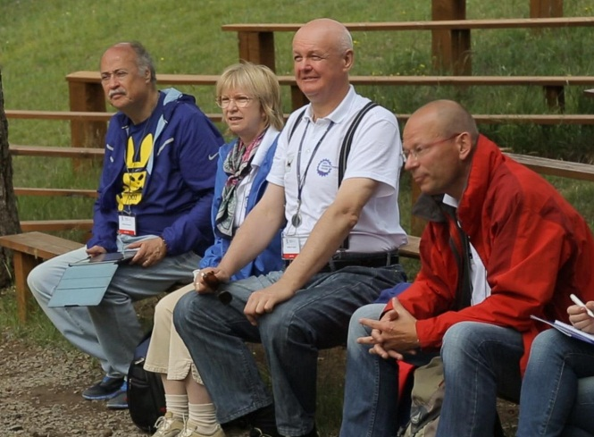
The Forum provides perfect opportunity to meet and negotiate with the heads of Federal and regional Executive authorities, heads of major industrial enterprises the issues of international cooperation, establishing business contacts, possibility of export contracts and investments, as well as promoting foreign companies at the Russian market.
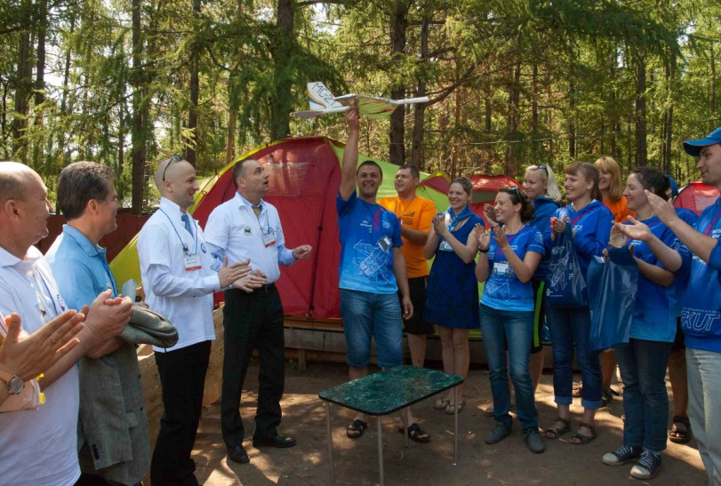
The Forum is well known for a wide international participation. For the last five years more than 100 delegations from 48 countries visited the Forum. Diplomatic missions, ambassadors, industrial associations and companies from many countries actively participated in the Forum.
The most numerous delegations were presented by the following countries: China, Brazil, India, Italy, Germany, France, Switzerland, Slovakia, Latvia, Poland, Hungary, Austria, Spain, Holland, Ireland, Slovenia, Macedonia, Malaysia, Mexico, Venezuela, Israel, Guatemala, Jordan, Syria, Croatia, Kazakhstan, etc.
The international nature of the Forum reveals perfect prospects both for regional enterprises and for young engineers. The enterprises will present their products and technologies to the guests and participants of the Forum, that will assist them in entering the world industrial market. And young engineers will get a chance to demonstrate their high qualifications.
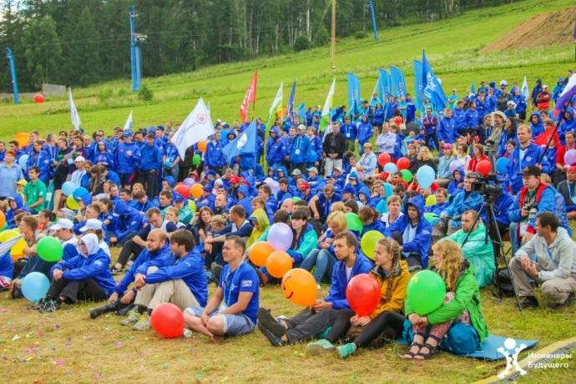
During the Forum young specialists will get additional knowledge and establish new business relations in order to enhance modern technologies at their companies.
The significance and importance of International Youth Industrial Forum "Engineers of the Future" are clearly demonstrated by results:
- an increased activity of young specialists at industrial enterprises;
- initiatives of talented engineers and designers were supported by managment of their companies. Quite a number of innovative projects have been implemented in production;
- the best young specialists were included in Expert Councils of the State Duma Industrial Committee in the following areas: development of defense-industrial complex, aircraft and space industry, development of technological base of engineering and machine tool industry. All this enabled them to participate in the international inter-parliamentary relations.

